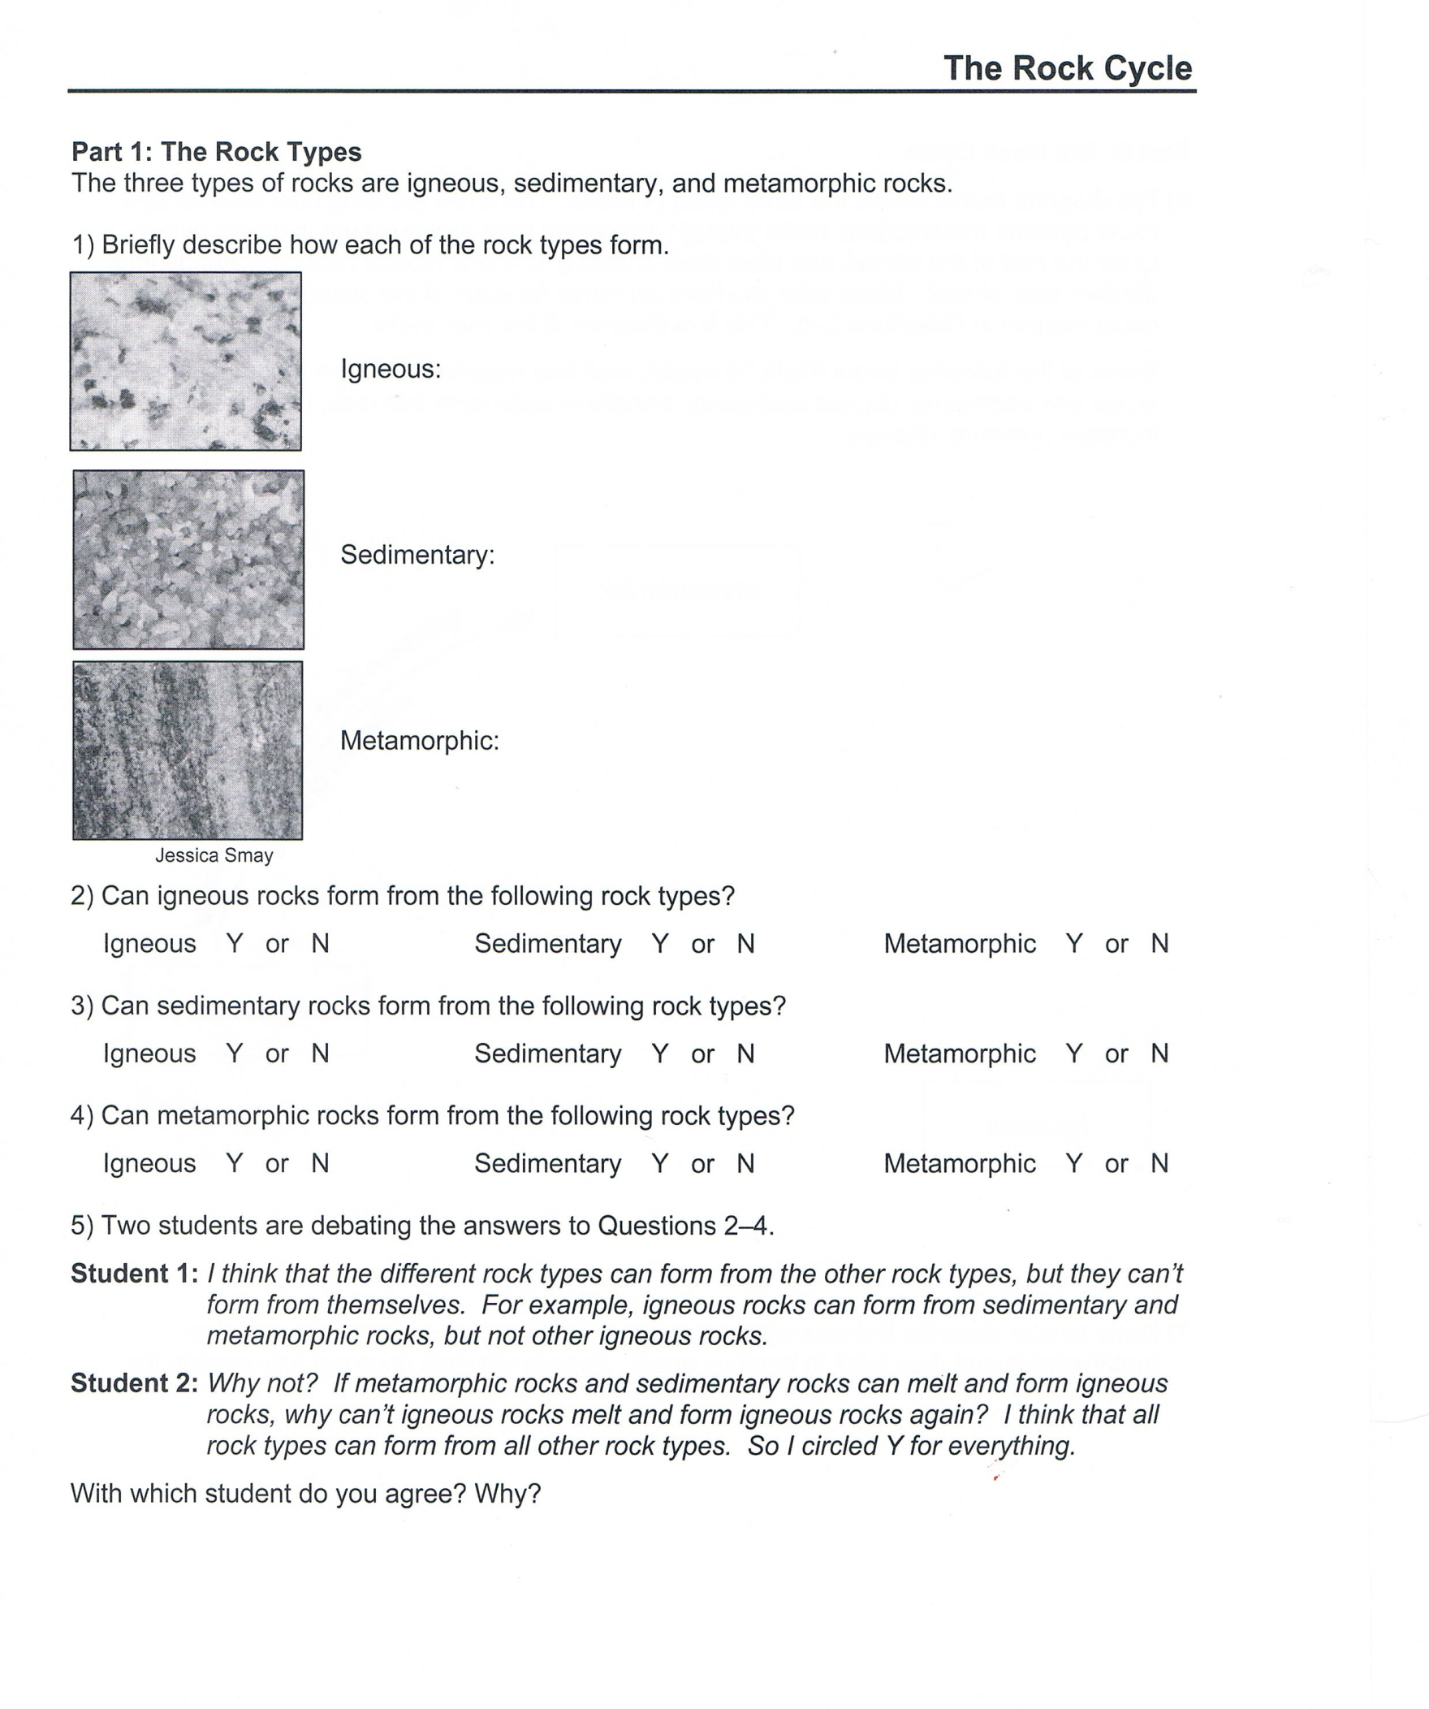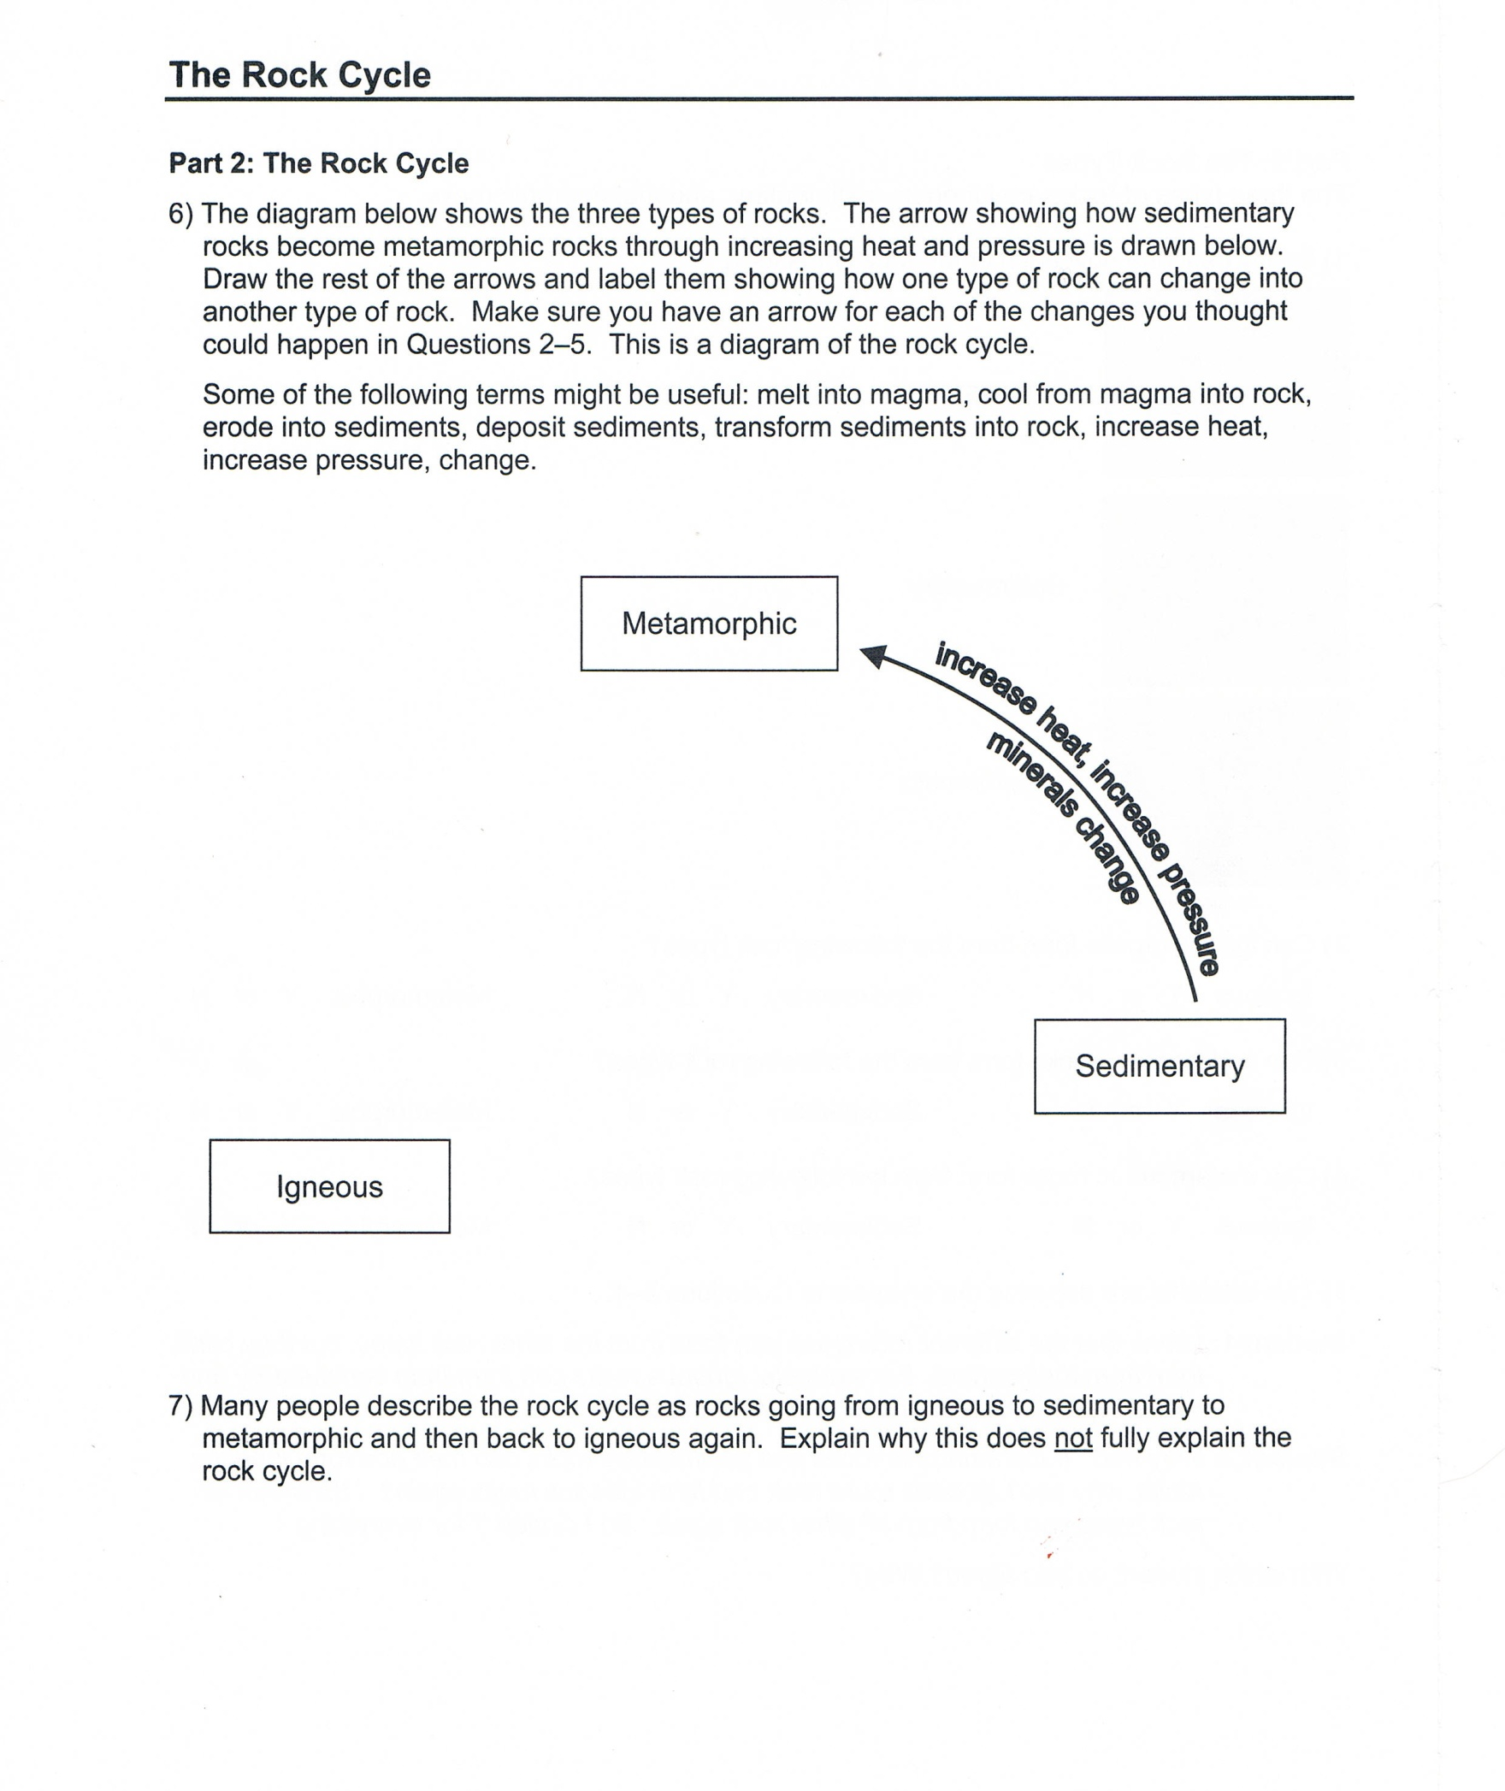
They are formed through crystallization process. Crystallization process involves cooling and solidification of lava which comes rises to the earth’s surface.

They are formed from other rocks due to changes of pressure or heat. The Earth is said to be in movements which causes rocks to be either squeezed or buried deeply. Due to this movement there is creation of heat and great pressure.

Sedimentary rocks are formed when the already existing rocks withers. The withered material then are transported to a certain point for deposition – the agents of transport can be water or wind. Deposition is then followed by compaction and the last step is cementation to form the rock.

I agree with student 2 because metamorphic rocks are formed from other rocks, sedimentary rocks are formed after some other rocks breaks down into particles which are washed or blown away and igneous rocks are formed after other rocks melts. Thus, it can be asserted that rocks are formed by altering other’s form and redistributed – renewal process.

The rock cycle process involves transformation between the three rock types metamorphic, sedimentary and igneous. Any type of rock can be converted into any other type, or into another rock of the same kind.

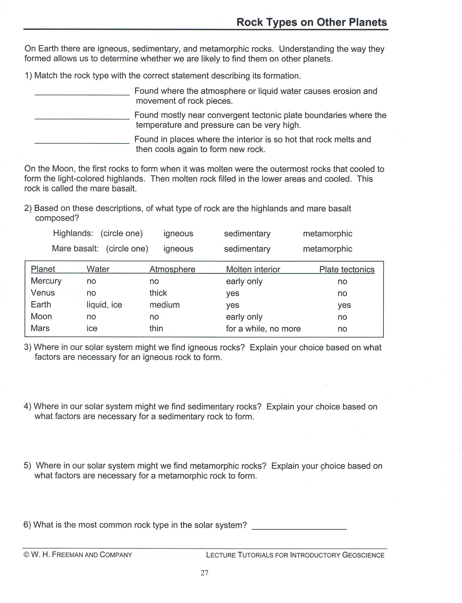
The sedimentary rocks can be found on earth because it is where all the agents that are involved during its formation are found. For instance, water and ice are involved in weathering and erosion processhence producing grains that are used to form the rocks.
Use the info in the table above
Metamorphic rocks
Igneous rocks
Sedimentary rocks
Basalt
The metamorphic rocks can be found in planets venus and earth. Metamorphic They are formed from other rocks due to changes of pressure or heat. The Earth is said to be in movements which causes rocks to be either squeezed or buried deeply. Due to this movement there is creation of heat and great pressure.

The igneous rocks can only be found on planet Earth because its formation includes the molten substance being exposed on to the surface and it is then deposited by water or ice.

